The following document displays the static prototypes that I created to give an idea of the project to our users. The idea over here is that the users will be using their smartphones to handle their devices.

### **Home user prototype:**

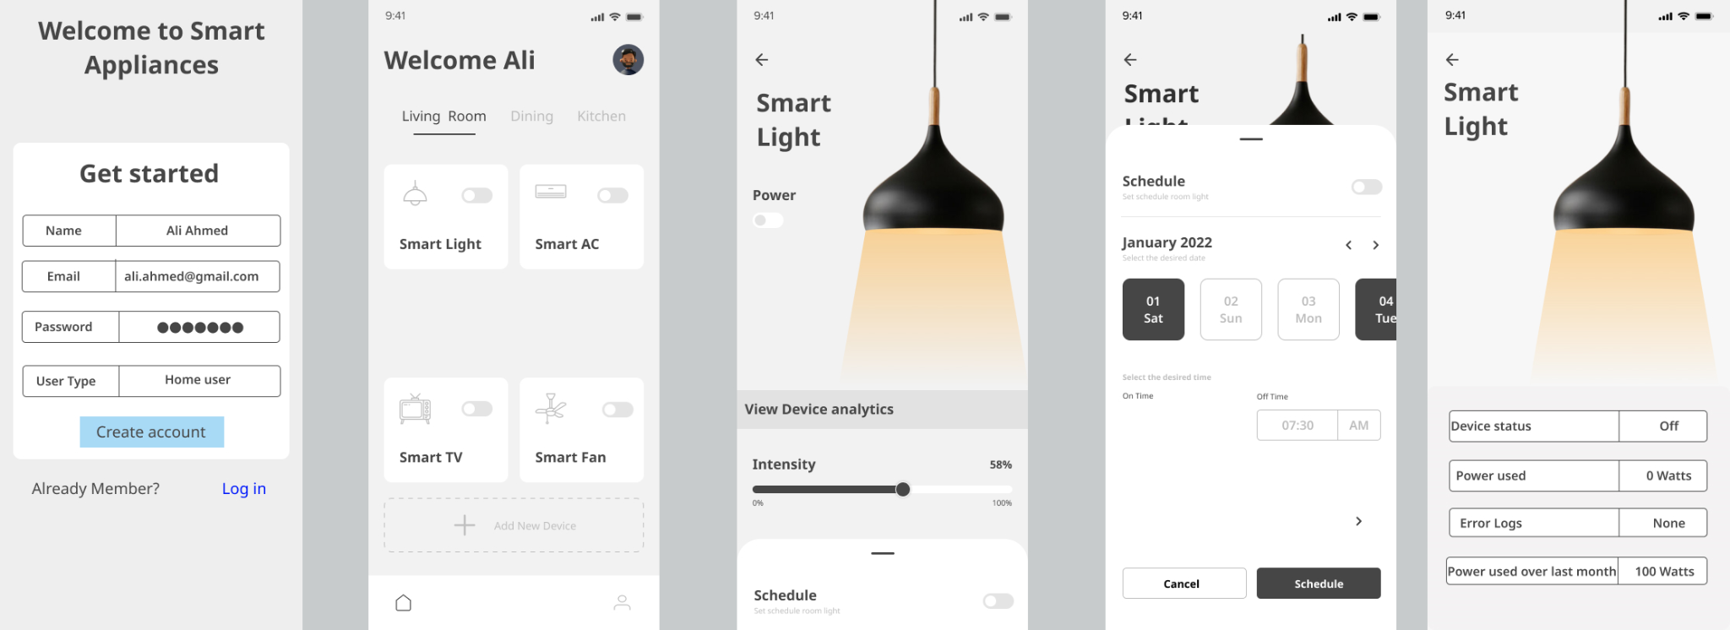

The prototype will be the same for business users with the difference that the second screen will have a security tag at its center to enable security mode.

### **Company user prototype:**

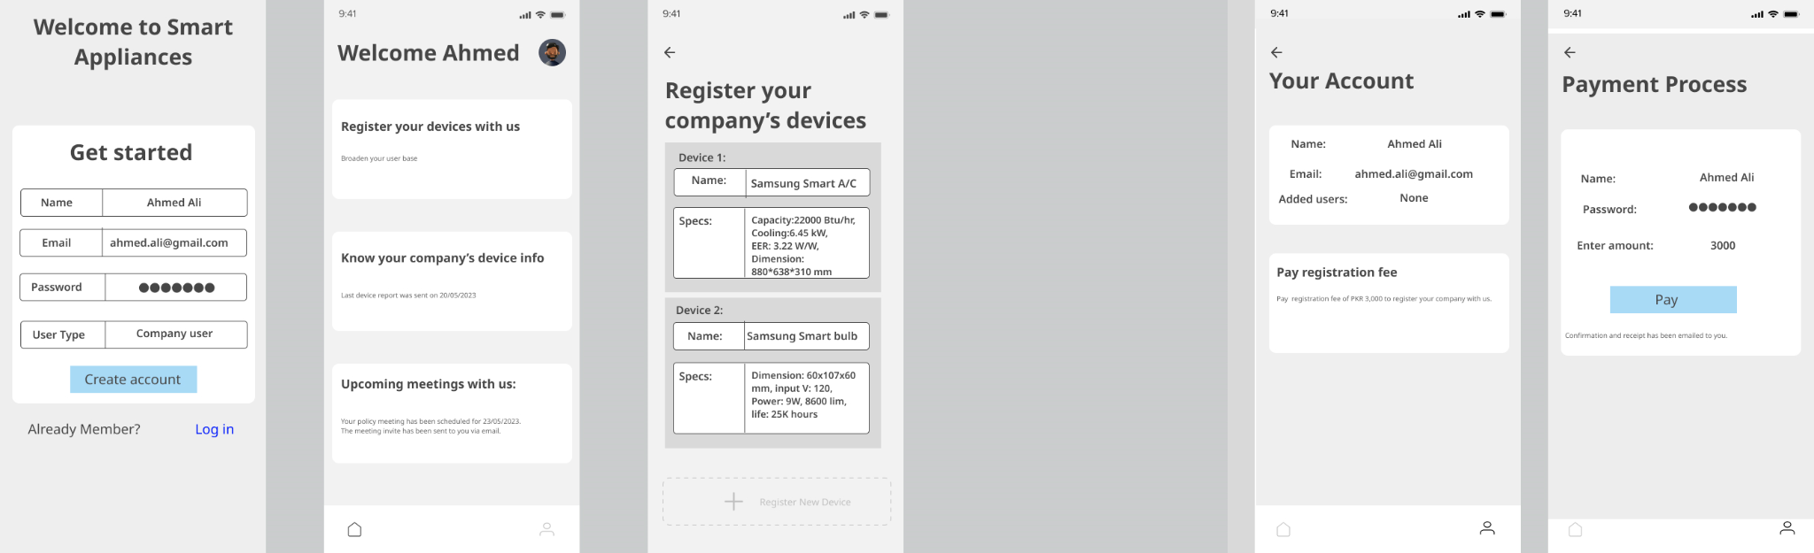

### **System admin prototype:**

